**Key Milestone 5: Final Report**



**DBMS Final Project**

**Submitted By:** Muhammad Saad Amjad Khan

**Project Group #19:**

Muhammad Ehzaz Khan (22pwcse2108)

Muhammad Saad Amjad Khan (22pwcse2133)

Muhammad Kamil Khan (22pwcse2174)

**Section:** B

**Submitted to:** Engr.Sumayyea Salahuddin

“On my honor, as student of University of Engineering and Technology, I have neither given nor received unauthorized assistance on this academic work”

Department of Computer Systems Engineering

University of Engineering and Technology Peshawar

**Project: Restaurant Management System**

# Implementation Details of Restaurant Management System

## **Introduction**

The Restaurant Management System (RMS) is a web-based application developed using Laravel (PHP framework) to streamline and digitize the operations of a restaurant. It handles orders, invoices, menus, customer details, and table bookings efficiently while ensuring a user-friendly interface for both admins and customers.

## **Technologies Used**

* Backend: PHP (Laravel 12)
* Frontend: HTML, CSS, Blade Templates
* Database: MySQL
* Tools: VS Code, XAMPP, Composer
* Libraries: Bootstrap (for UI), Laravel Eloquent ORM

## **Modules Implemented**

## **User Authentication**

* Users can register and log in using Laravel’s built-in authentication.
* Admin has privileges to view and manage all modules.

## **Food/Menu Management**

* Admin can add, update, and delete food items.
* Each food item includes:
  + Name
  + Description
  + Price
  + Category
  + Image (uploaded and stored in public folder)

**Order Management:**

* Users can place orders from the available food menu.
* Orders are stored in the database and linked to both user and food entities.
  + Admin can view all orders placed with details such as:
  + Food ordered
  + Quantity

## Customer information

## Total cost

## Order status

## **Invoice Generation**

* Admin can generate invoices for completed orders.
* Each invoice includes:
  + Invoice ID
  + Linked order details
  + Date & time
  + Total bill amount
  + Payment status

## **Table Reservation**

* Users can reserve tables by providing:
  + Name
  + Phone number
  + Date and time
  + Number of people
  + Admin can manage all reservations and mark them as confirmed or cancelled.

## **Review & Feedback**

* Users can submit reviews and feedback after ordering.
* Admin can view and moderate these reviews.

## **Database Design**

## **Main Tables**

* users: Stores user information (id, name, email, password, phone, address).
* foods: Stores menu items (id, name, price, description, image).
* orders: Links users to food items with quantity and status.
* invoices: Generated for completed orders.
* reservations: Stores table booking information.
* reviews: Stores customer reviews for food or service.

## **Admin Dashboard**

* Displays key metrics:
* Total Orders
* Completed Orders
* Revenue Generated
* Reservations Count
* Provides quick links to manage each module.
* Uses Laravel Blade templates with Bootstrap components.

## **User Interface**

* Built using HTML/CSS with Laravel Blade.
* Clean navigation bar.
* Food menu displayed as responsive cards.
* Reservation and order forms with validation.
* Admin pages with tables and actionable buttons.

## **Error Handling and Validation**

* Server-side validation using Laravel’s validate() method.
* Try-catch blocks implemented for database operations.
* Custom error pages for 404 and 500.

## **Security Measures**

* Passwords hashed using Laravel's built-in bcrypt().
* Middleware used to protect admin routes.
* CSRF protection enabled by default.
* Mass assignment protection using $fillable.

## **Testing and Deployment**

* Manual testing performed on:
* Order placement
* Invoice generation
* Reservation booking
* Deployed locally using XAMPP.
* Database migrations handled via Laravel Artisan.

**Business Rules for Restaurant Management System:**

1. users

**Business Role:**  
Stores the details of customers who use the restaurant system. Each user can browse the menu, add items to their cart, place orders, leave reviews, and book tables.

**Key Functional Rules:**

* One user can have multiple orders.
* One user can post multiple reviews.
* One user can have multiple invoices and carts.
* Each user is uniquely identified by their ID.

1. employees

**Business Role:**  
Manages records of restaurant staff such as waiters, chefs, and managers. Employees are assigned to handle orders and work shifts.

**Key Functional Rules:**

* Each employee has a designated shift.
* Employees may be linked to handling one or more orders.

1. food

**Business Role:**  
Maintains the master list of food items offered by the restaurant. This includes information like name, description, price, and image for display.

**Key Functional Rules:**

* Food items appear in the menu.
* Food items are referenced in orders, cart, and reviews.

1. orders

**Business Role:**  
Stores all placed orders made by users. Each order links a user to a food item and the employee responsible for fulfilling it. Contains the order’s current status and amount.

**Key Functional Rules:**

* Each order belongs to one user.
* Each order is assigned to one employee.
* Each order is for one food item (in flattened design).
* Order statuses include: Pending, Completed, Cancelled.

1. tables

**Business Role:**  
Stores information about the physical dining tables in the restaurant including their seating capacity and current availability status.

**Key Functional Rules:**

* Each table can be reserved (linked via books).
* Table status can be: Available, Reserved, Occupied.

1. books

**Business Role:**  
Manages customer reservations for dining tables. Tracks which user reserved which table at what date and time, for how many guests.

**Key Functional Rules:**

* A user can make multiple bookings.
* A table can have multiple bookings (on different dates/times).
* Booking includes time and number of guests.

1. reviews

**Business Role:**  
Captures feedback from users about food items. Each review includes a rating and review text, tied to a specific food item.

**Key Functional Rules:**

* A user can review multiple food items.
* A food item can have many reviews.
* Ratings help in calculating average food quality scores.

1. carts

**Business Role:**  
Temporarily stores food items that a user is planning to order. Acts like a shopping basket before converting to an order.

**Key Functional Rules:**

* A cart is user-specific.
* Items in the cart are not yet part of any official order.
* Cart is cleared when the order is placed.

1. invoice

**Business Role:**  
Keeps a financial record of each completed order. Used for billing, accounting, and payment tracking.

**Key Functional Rules:**

* Each invoice belongs to a user and an order.
* Invoices store final amount, status (e.g., Paid, Unpaid), and timestamp.
* One invoice per order.

**Main Entities & Their Description:**

1. **users:**

|  |  |  |
| --- | --- | --- |
| **Attributes** | **Datatypes** | **Name in Database** |
| **id** (PK) | Integer | id |
| name | String | name |
| phone | String | phone |
| email | String | email |
| address | String | address |
| password | string | password |

1. **employees:**

|  |  |  |
| --- | --- | --- |
| **Attributes** | **Datatypes** | **Name in Database** |
| **id** (PK) | Integer | id |
| name | String | name |
| role | String | role |
| phone | String | phone |
| salary | Integer | salary |
| shift_timing | DateTime | shift |
| date_of_joining | Date | date_joining |

1. **foods:**

|  |  |  |
| --- | --- | --- |
| **Attributes** | **Datatypes** | **Name in Database** |
| **id** (PK) | Integer | id |
| title | String | title |
| detail | String | detail |
| price | Integer | price |
| image | String | image |

1. **orders:**

|  |  |  |
| --- | --- | --- |
| **Attributes** | **Datatypes** | **Name in Database** |
| **id** (PK) | Integer | id |
| **user_id** (FK) | Integer | user_id |
| **food_id** (FK) | Integer | food_id |
| **Employee_id** (FK) | integer | Employee_id |
| amount | Integer | amount |
| status | String | status |

1. **tables:**

|  |  |  |
| --- | --- | --- |
| **Attributes** | **Datatypes** | **Name in Database** |
| **id**(PK) | Integer | id |
| capacity | Integer | capacity |
| details | String | detail |
| status | String | status |

1. **books:**

|  |  |  |
| --- | --- | --- |
| **Attributes** | **Datatypes** | **Name in Database** |
| **id** (PK) | Integer | id |
| **table_id** (FK) | Integer | table_id |
| phone | String | phone |
| guests | Integer | guests |
| date | DateTime | date |
| time | DateTime | time |

1. **reviews:**

|  |  |  |
| --- | --- | --- |
| **Attributes** | **Datatypes** | **Name in Database** |
| **id** (PK) | Integer | id |
| **food_id** (FK) | Integer | food_id |
| review | String | review |
| rating | Integer | rating |
| date | DateTime | date |

1. **carts:**

|  |  |  |
| --- | --- | --- |
| **Attributes** | **Datatypes** | **Name in Database** |
| **id** (PK) | Integer | id |
| **user_id** (FK) | Integer | user_id |
| **food_id** (FK) | Integer | food_id |
| quantity | Integer | quantity |

1. **invoice:**

|  |  |  |
| --- | --- | --- |
| **Attributes** | **Datatypes** | **Name in Database** |
| **id** (PK) | Integer | id |
| **order_id** (FK) | Integer | order_id |
| **user_id** (FK) | Integer | user_id |
| amount | Integer | amount |
| status | String | status |
| date | DateTime | date |

**Finalized Conceptual Schema:**

**ERD (Entity Relationship Diagram):**

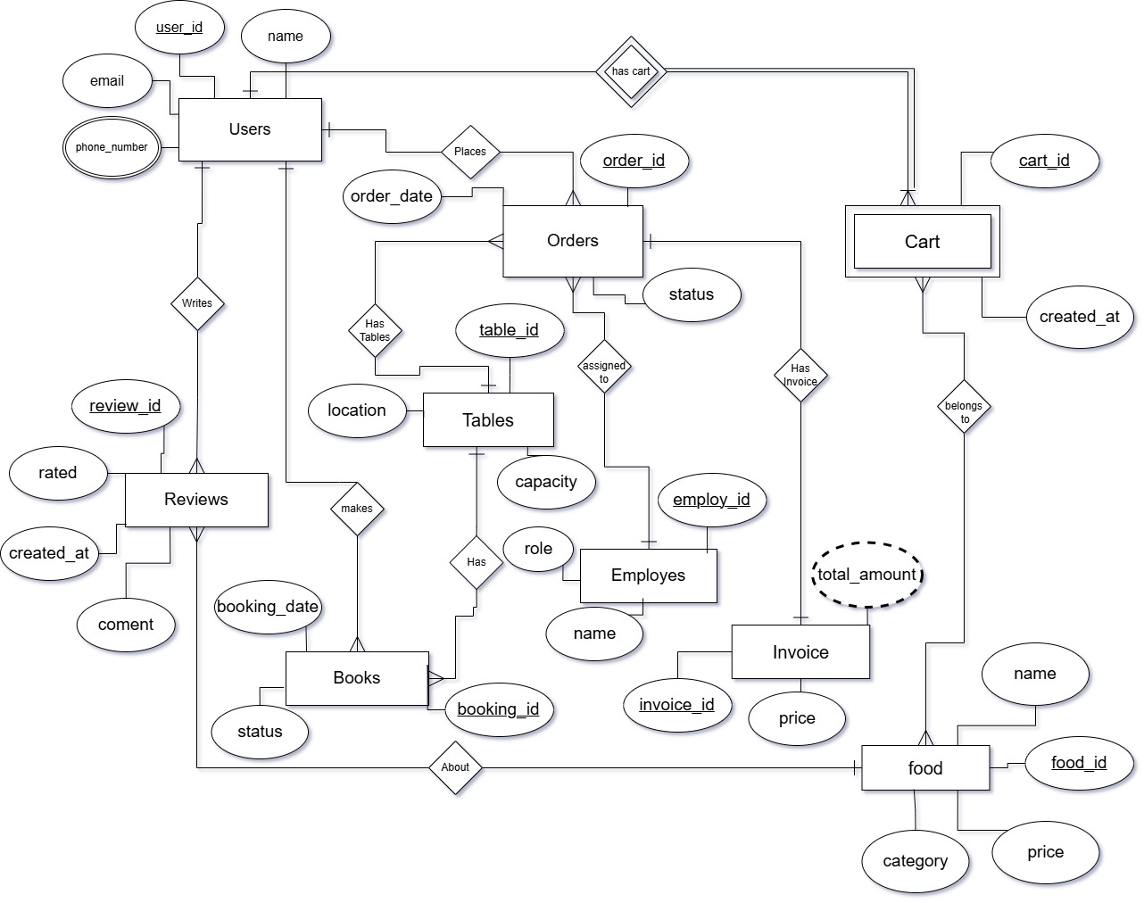

**EERD (Enhanced Entity Relationship Diagram):**

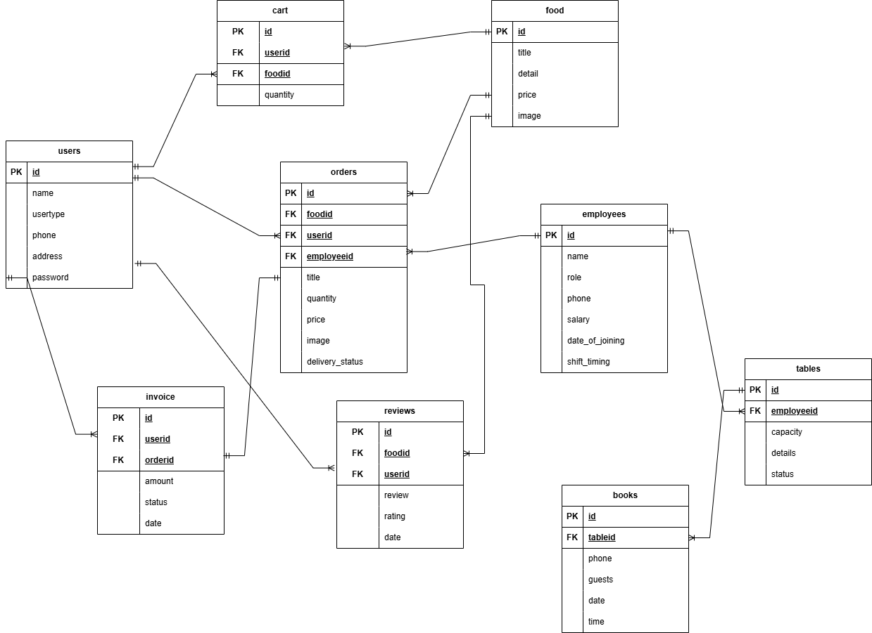

**Final Normalized Forms:**

users(id PK, name, phone, email, address, password)

employees(id PK, name, role, phone, salary, date_of_joining, shift_timing)

books(id PK, table_id FK, phone, guests, date)

carts(id PK, user_id FK, food_id FK, quantity)

tables(id PK, details, capacity, status)

orders(id PK, food_id FK, user_id FK, employee_id FK, total_amount, order_status)

reviews(id PK, food_id FK, user_id FK, review, rating, date)

invoice(id PK, order_id FK, user_id FK, amount, status, date)

**Table:** users

**Metadata:**

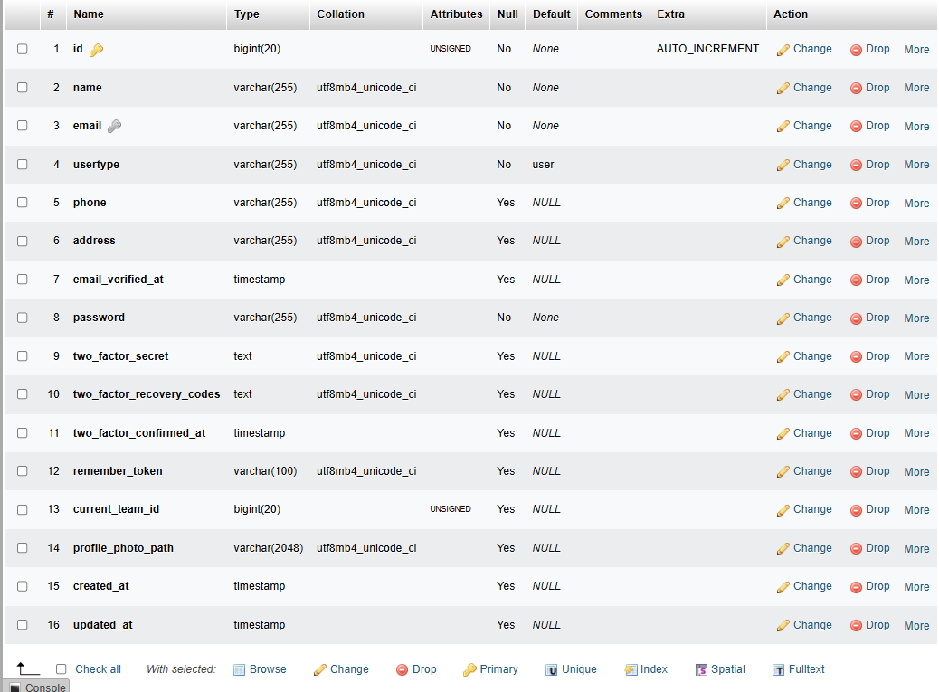

**Sample Data:**

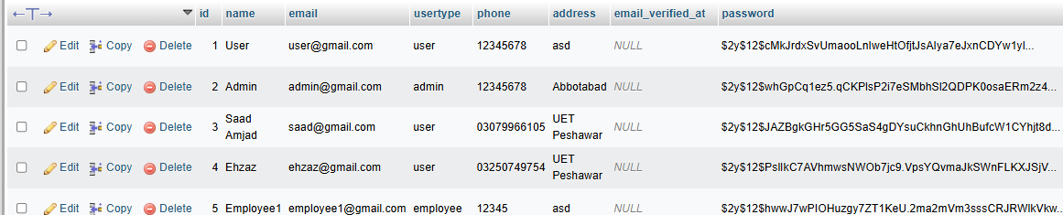

**SQL Queries:**

CREATE TABLE users (

id INT PRIMARY KEY,

name VARCHAR(100),

phone VARCHAR(15),

email VARCHAR(100),

address TEXT,

password VARCHAR(100)

);

INSERT INTO users (id, name, email, usertype, phone, address, password)

VALUES (2, 'Admin', 'admin@gmail.com', 'admin', '12345678', 'Abbotabad', '12345678');

INSERT INTO users (id, name, email, usertype, phone, address, password)

VALUES (3, 'Saad Amjad', 'saad@gmail.com', 'user', '03079966105', 'UET Peshawar', '12345678');

**Table:** employees

**Metadata:**

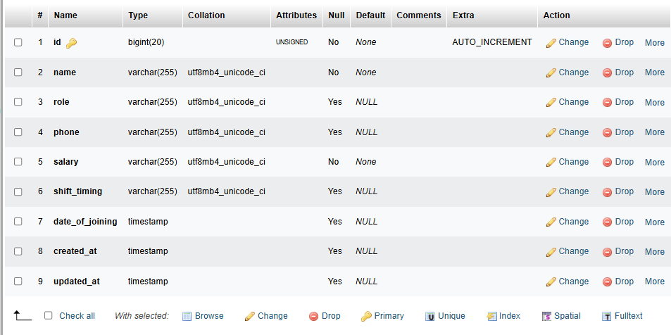

**Sample Data:**

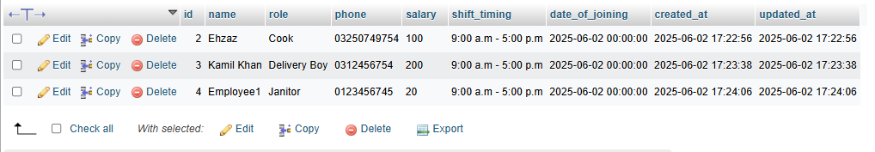

**SQL Queries:**

CREATE TABLE employees (

id INT PRIMARY KEY,

name VARCHAR(100),

role VARCHAR(50),

phone VARCHAR(15),

salary INT,

shift TIMESTAMP,

date_joining DATE

);

INSERT INTO employees (id, name, role, phone, salary, shift_timing, date_of_joining)

VALUES (2, 'Ehzaz', 'Cook', '03250749754', 100, '9:00 a.m - 5:00 p.m', '2025-06-02 00:00:00');

INSERT INTO employees (id, name, role, phone, salary, shift_timing, date_of_joining)

VALUES (3, 'Kamil Khan', 'Delivery Boy', '0312456754', 200, '9:00 a.m - 5:00 p.m', '2025-06-02 00:00:00);

INSERT INTO employees (id, name, role, phone, salary, shift_timing, date_of_joining)

VALUES (4, 'Employee1', 'Janitor', '0123456745', 20, '9:00 a.m - 5:00 p.m', '2025-06-02 00:00:00');

**Table:** food

**Metadata:**

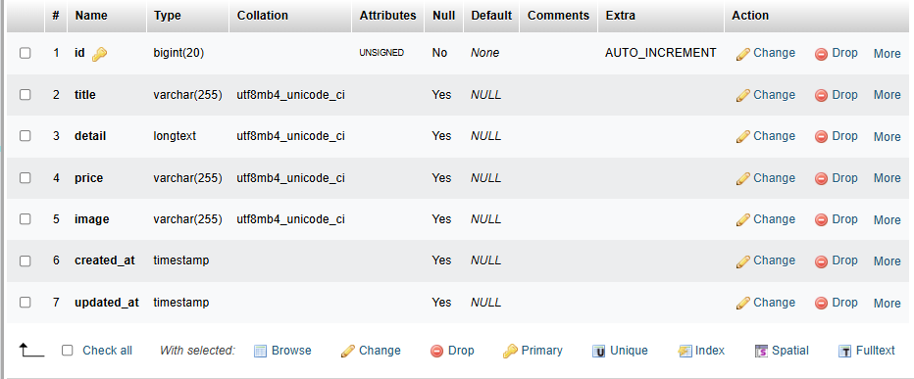

**Sample Data:**

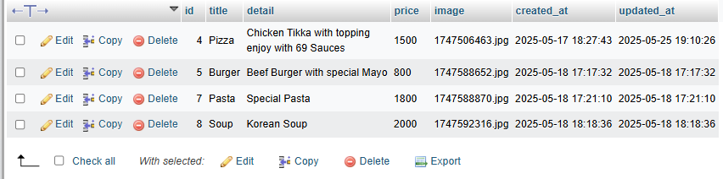

**SQL Queries:**

CREATE TABLE food_item (

id INT PRIMARY KEY,

title VARCHAR(100),

detail TEXT,

price INT,

image VARCHAR(255)

);

INSERT INTO food (id, title, detail, price, image)

VALUES (4, 'Pizza', 'Chicken Tikka with topping enjoy with 69 Sauces', 1500, ‘1747506463.jpg’);

INSERT INTO food (id, title, detail, price, image)

VALUES (5, 'Burger', 'Beef Burger with Special Mayo', 800, ‘1747588652.jpg’);

INSERT INTO food (id, title, detail, price, image)

VALUES (7, 'Pasta', 'Special Pasta', 1800, ‘1747588870.jpg’);

INSERT INTO food (id, title, detail, price, image)

VALUES (8, 'Soup', Korean Soup', 2000, ‘1747592316.jpg’);

**Table:** orders

**Metadata:**

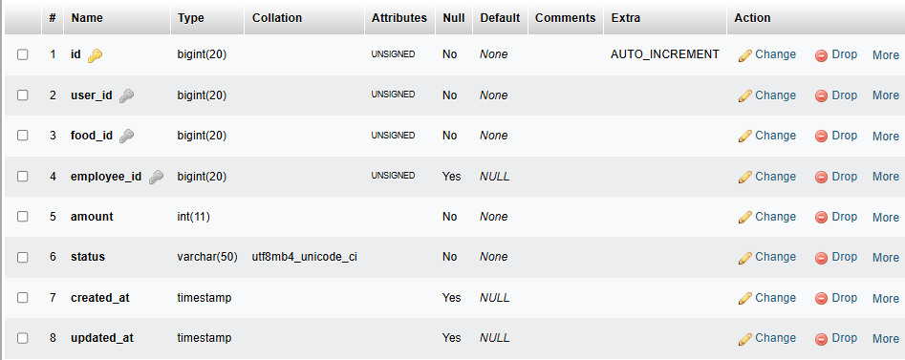

**Sample Data:**

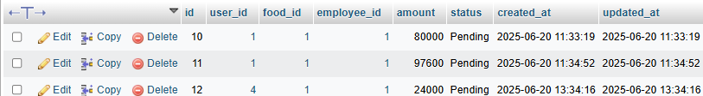

**SQL Queries:**

CREATE TABLE orders (

id INT PRIMARY KEY,

user_id INT,

food_id INT,

employee_id INT,

amount INT,

status VARCHAR(50),

FOREIGN KEY (user_id) REFERENCES users(id),

FOREIGN KEY (food_id) REFERENCES food_item(id),

FOREIGN KEY (employee_id) REFERENCES employees(id)

);

INSERT INTO orders (id, user_id, food_id, employee_id, amount, status)

VALUES (10, 1, 1, 1, 8000, Pending)

INSERT INTO orders (id, user_id, food_id, employee_id, amount, status)

VALUES (11, 1, 1, 1, 8000, Pending)

INSERT INTO orders (id, user_id, food_id, employee_id, amount, status)

VALUES (12, 1, 1, 1, 8000, Pending)

**Table:** tables

**Metadata:**

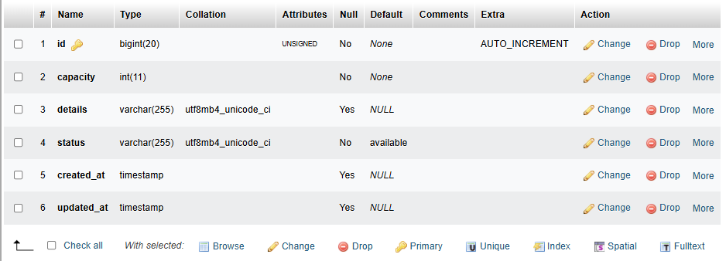

**Sample Data:**

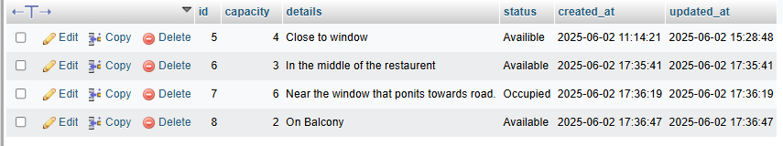

**SQL Queries:**

CREATE TABLE tables (

id INT PRIMARY KEY,

capacity INT,

detail TEXT,

status VARCHAR(50)

);

INSERT INTO tables (id, capacity, details, status)

VALUES (5, 4, ‘Close to window’, ‘Availible’)

INSERT INTO tables (id, capacity, details, status)

VALUES (6, 3, ‘In the middle of the restaurant’, ‘Available’)

INSERT INTO table (id, capacity, details, status)

VALUES (7, 6, ‘Near the window that points towards road.’, ‘Occupied’)

INSERT INTO tables (id, capacity, details, status)

VALUES (8, 2, ‘On Balcony’, ‘Available’)

**Table:** reviews

**Metadata:**

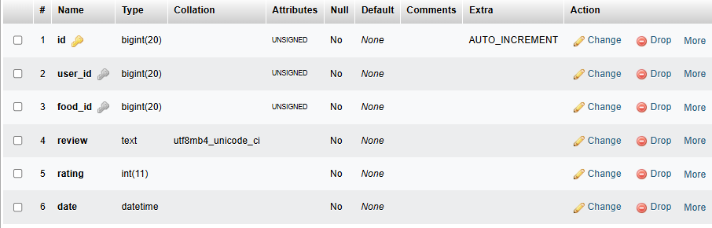

**Sample Data:**

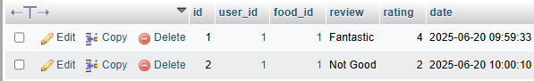

**SQL Queries:**

CREATE TABLE reviews (

id INT PRIMARY KEY,

user_id INT,

food_id INT,

review TEXT,

rating INT,

date DATETIME,

FOREIGN KEY (food_id) REFERENCES food_item(id)

);

INSERT INTO reviews (id, user_id, food_id, review, rating, date)

VALUES (1, 1, 1, ‘Fantastic’, 4, 2025-06-20)

INSERT INTO reviews (id, user_id, food_id, review, rating, date)

VALUES (2, 1, 1, ‘Not Good’, 2, 2025-06-20)

**Table:** books

**Metadata:**

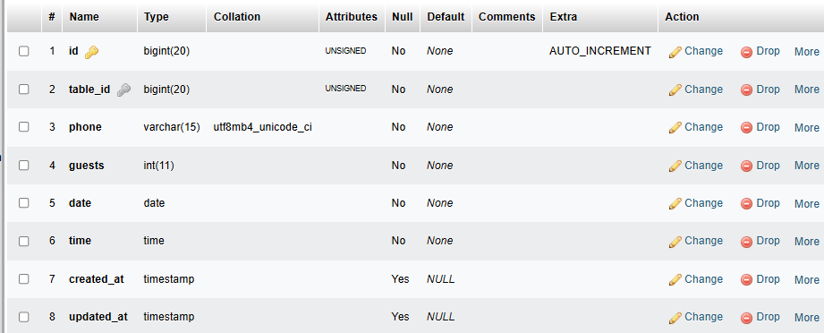

**Sample Data:**



**SQL Queries:**

CREATE TABLE books (

id INT PRIMARY KEY,

table_id INT,

phone VARCHAR(15),

guests INT,

date DATETIME,

time DATETIME,

FOREIGN KEY (table_id) REFERENCES tables(id)

);

INSERT INTO books (id, table_id, phone, guest, date, time)

VALUES (1, 1, +923429233995, 4, ‘2025-06-26’, ’22:44’)

**Table:** carts

**Metadata:**

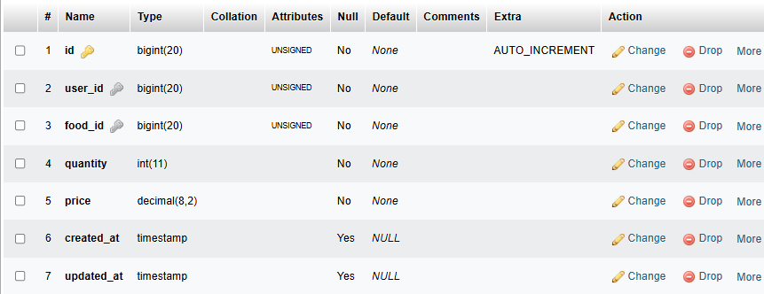

**Sample Data:**

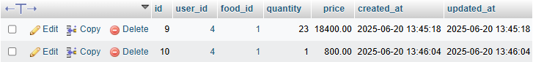

**SQL Queries:**

CREATE TABLE carts (

id INT PRIMARY KEY,

user_id INT,

food_id INT,

quantity INT,

price INT,

FOREIGN KEY (user_id) REFERENCES users(id),

FOREIGN KEY (food_id) REFERENCES food_item(id)

);

INSERT INTO carts (id, user_id, food_id, quantity, price)

VALUES (9, 4, 1, 23, 18400)

INSERT INTO carts (id, user_id, food_id, quantity, price)

VALUES (10, 4, 1, 1, 800)

**Table:** invoice

**Metadata:**

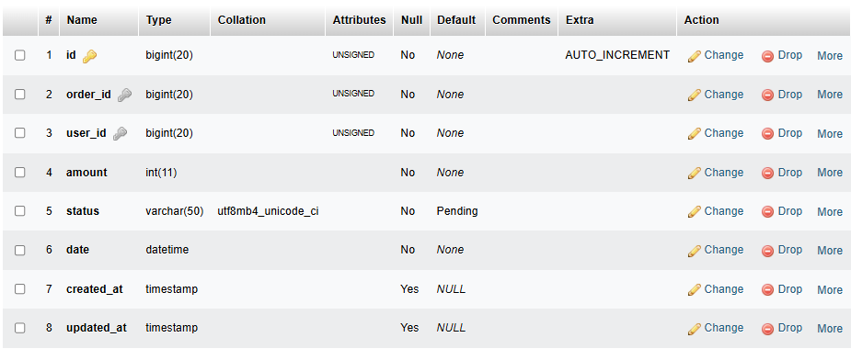

**Sample Data:**

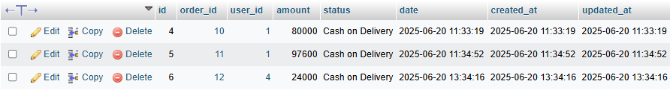

**SQL Queries:**

CREATE TABLE invoice (

id INT PRIMARY KEY,

order_id INT,

user_id INT,

amount INT,

status VARCHAR(50),

date DATETIME,

FOREIGN KEY (order_id) REFERENCES orders(id),

FOREIGN KEY (user_id) REFERENCES users(id));

INSERT INTO invoice (id, order_id, user_id, amount, status, date)

VALUES (4, 10, 1, 80000, ‘Cash on Delivery’, 2025-06-20)

INSERT INTO invoice (id, order_id, user_id, amount, status, date)

VALUES (5, 11, 1, 97600, ‘Cash on Delivery’, 2025-06-20)

**COMPREHENSIVE IMPLEMENTATION DETAILS (LARAVEL):**

**Home page:**

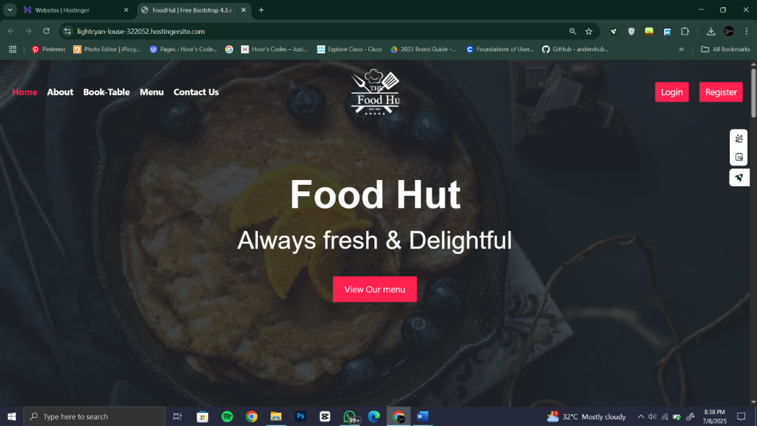

**Food menu:**

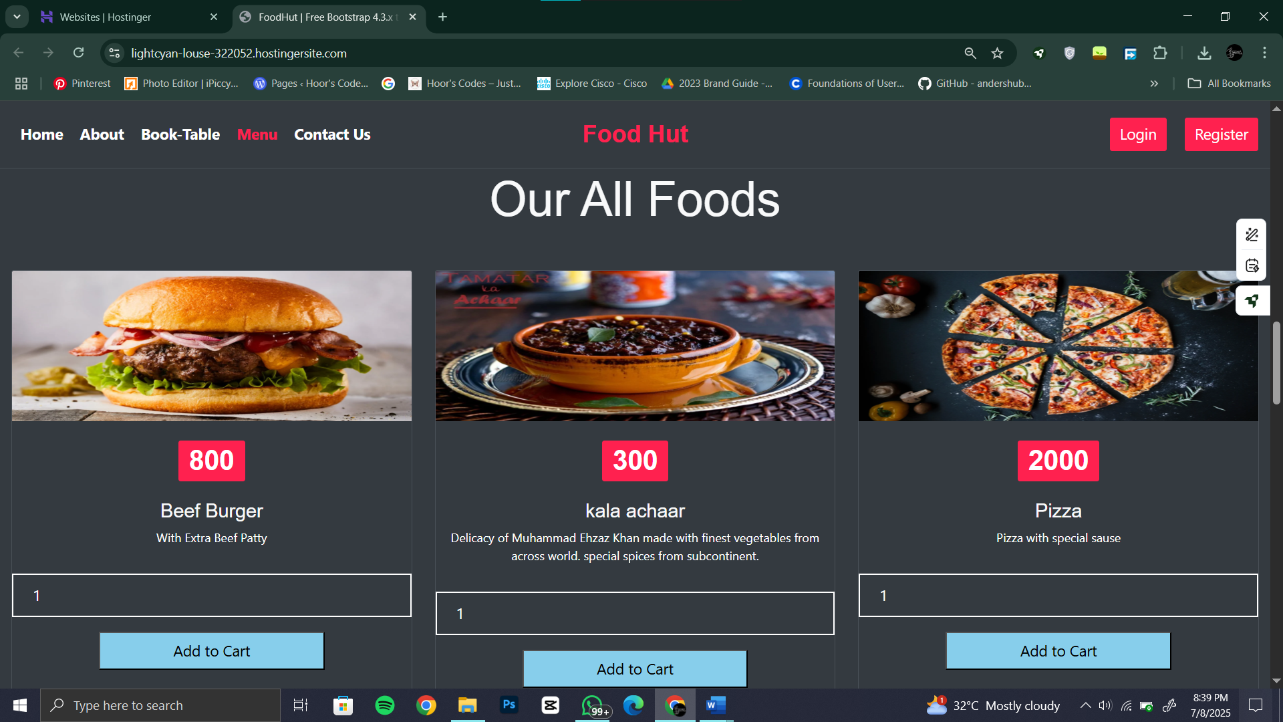

**Login page:**

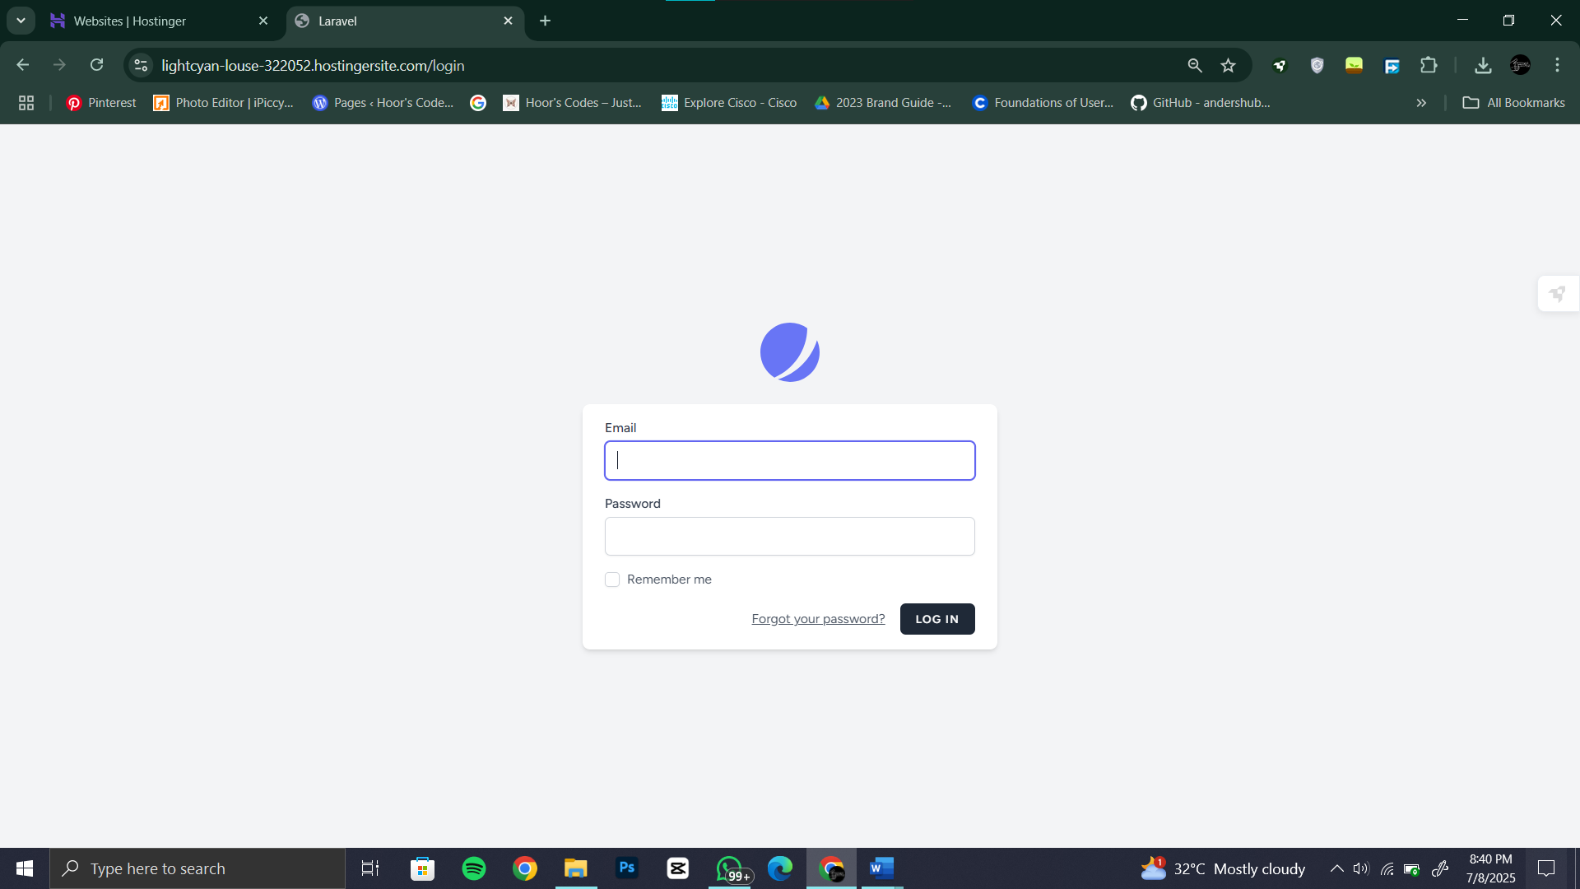

**Table booking:**

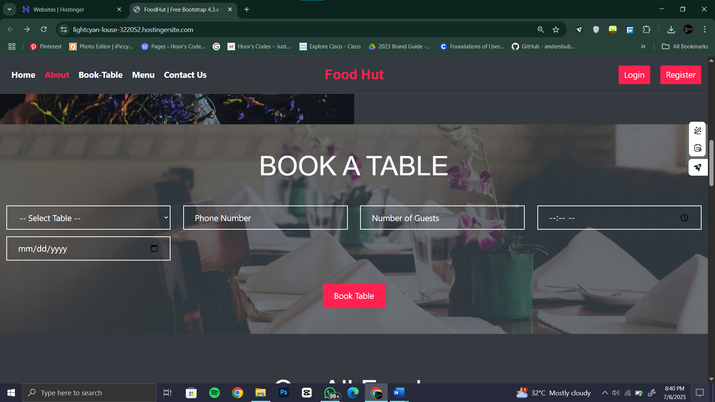

**Reviews :**

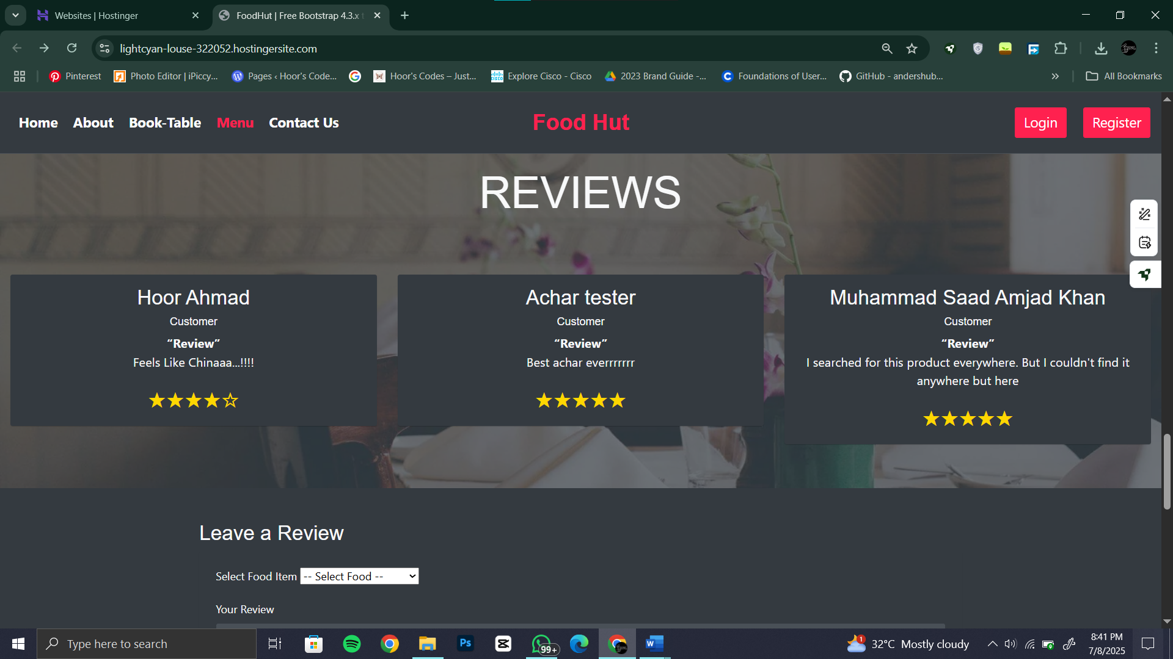

**Contact us:**

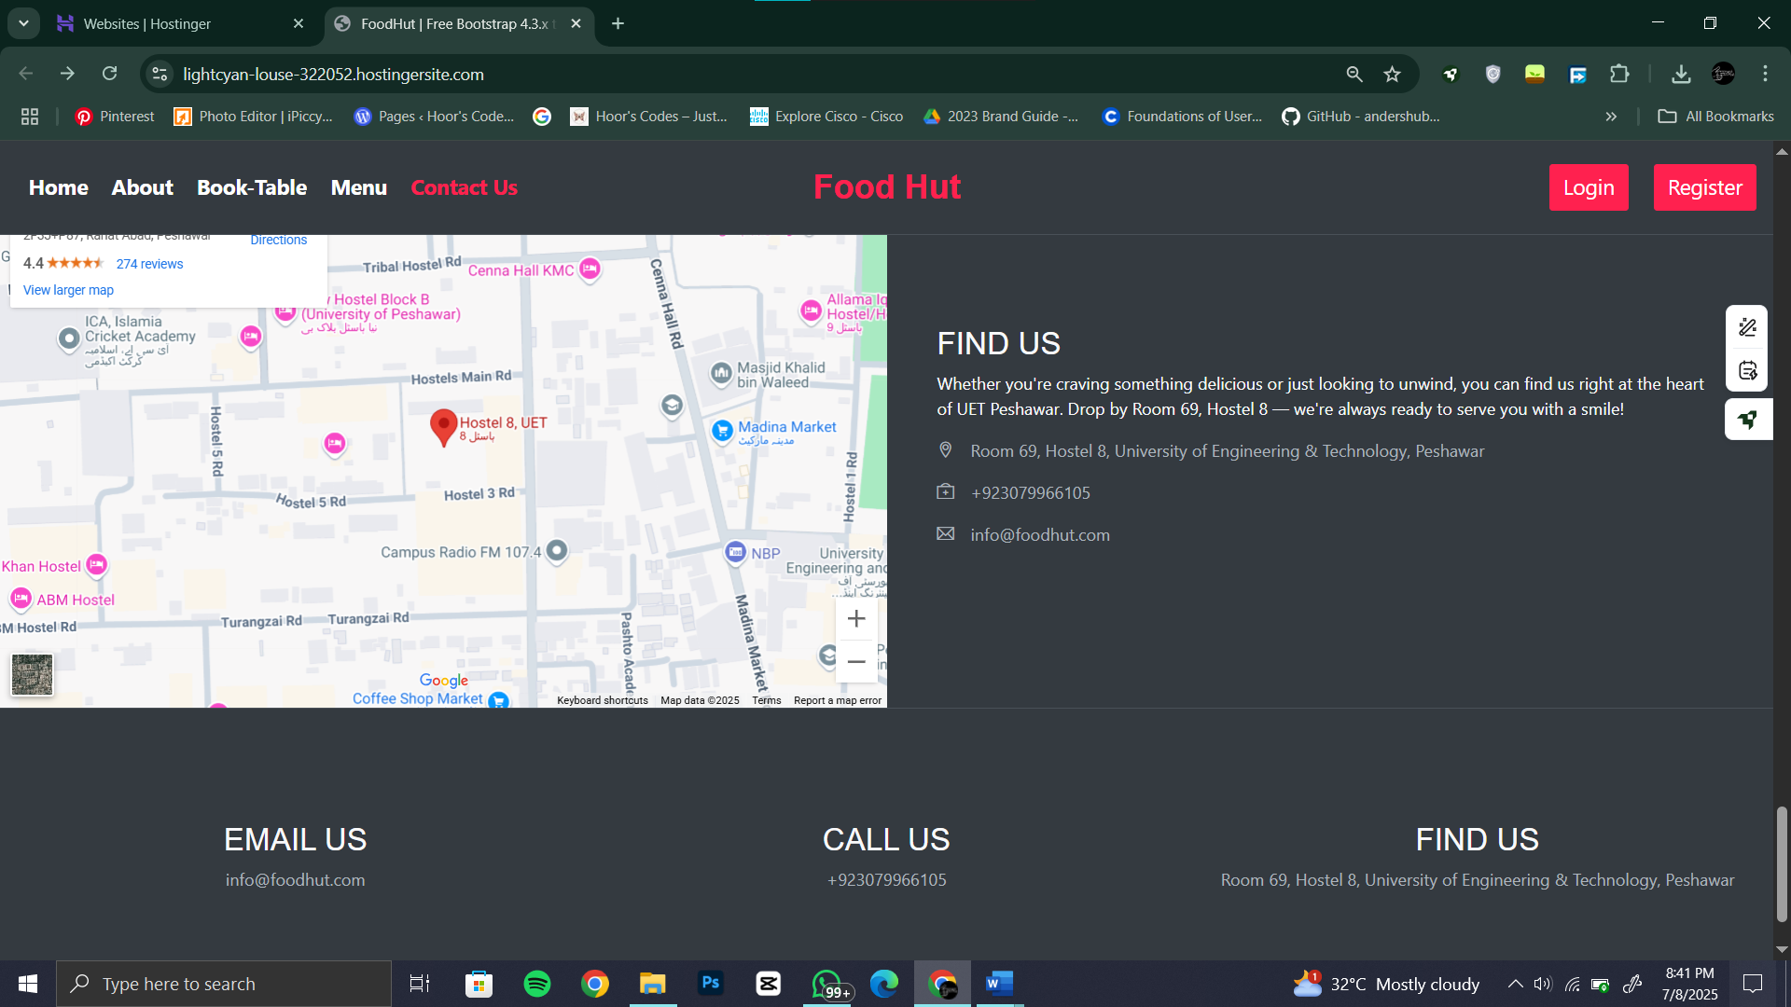

**View cart from customer credentials:**

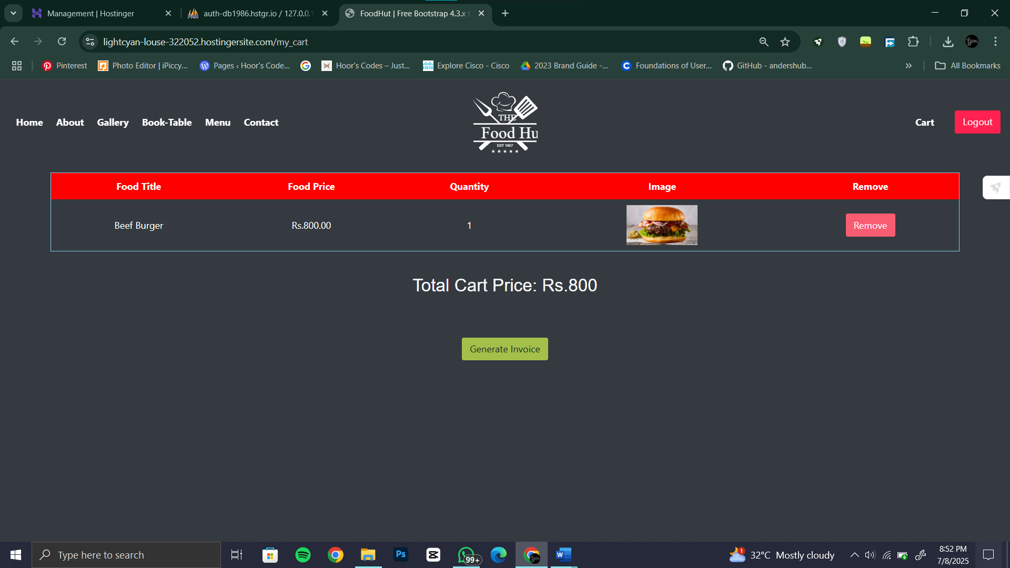

**Generate invoice for customer:**

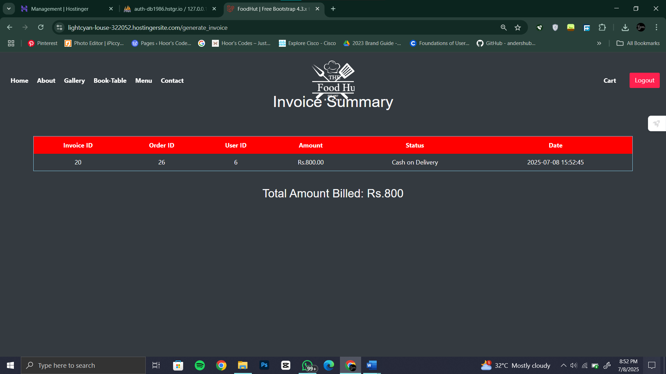

**Admin dashboard:**

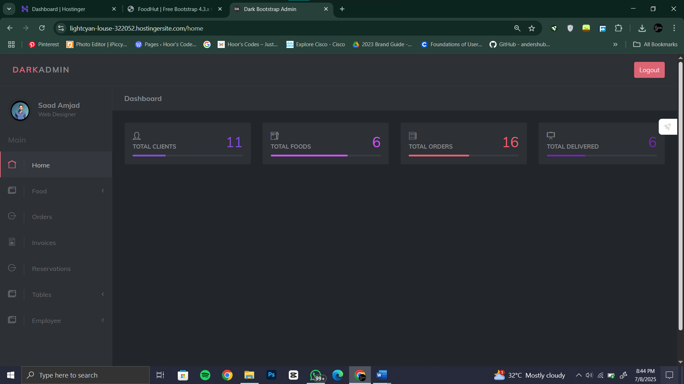

**Add food from admin panel:**

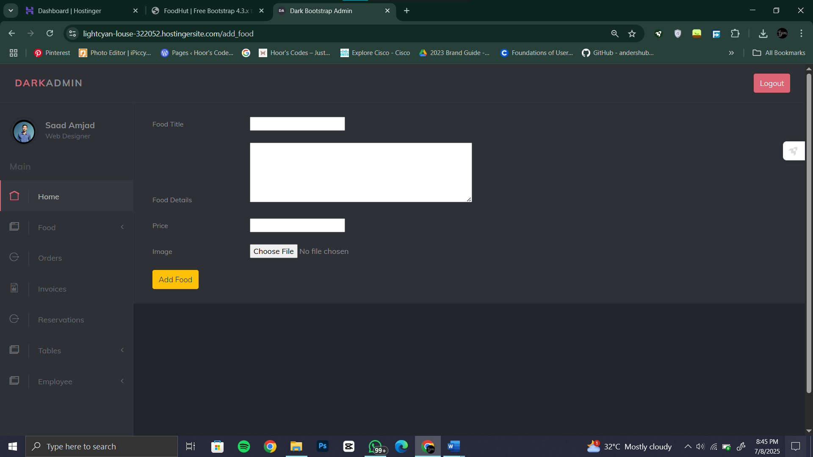

**View all the food from admin panel:**

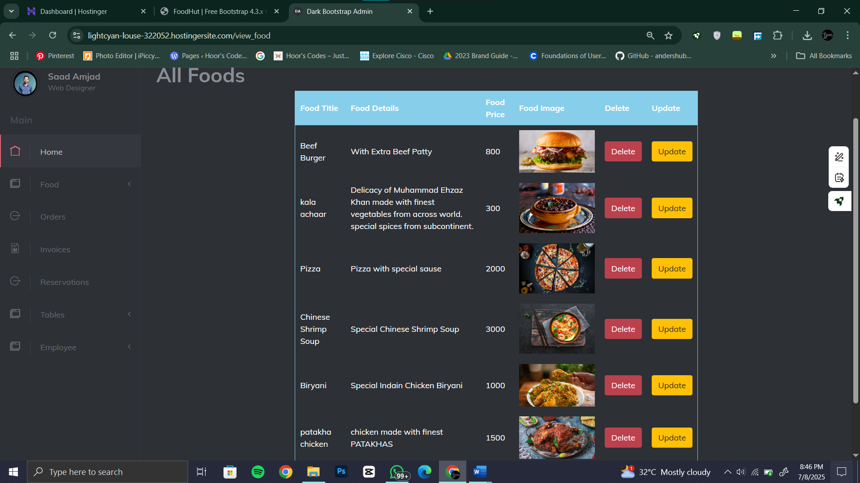

**View all the orders and their status from admin panel:**

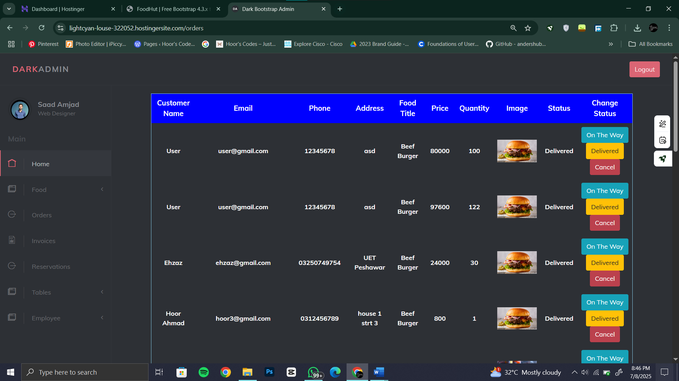

**All invoices from admin panel:**

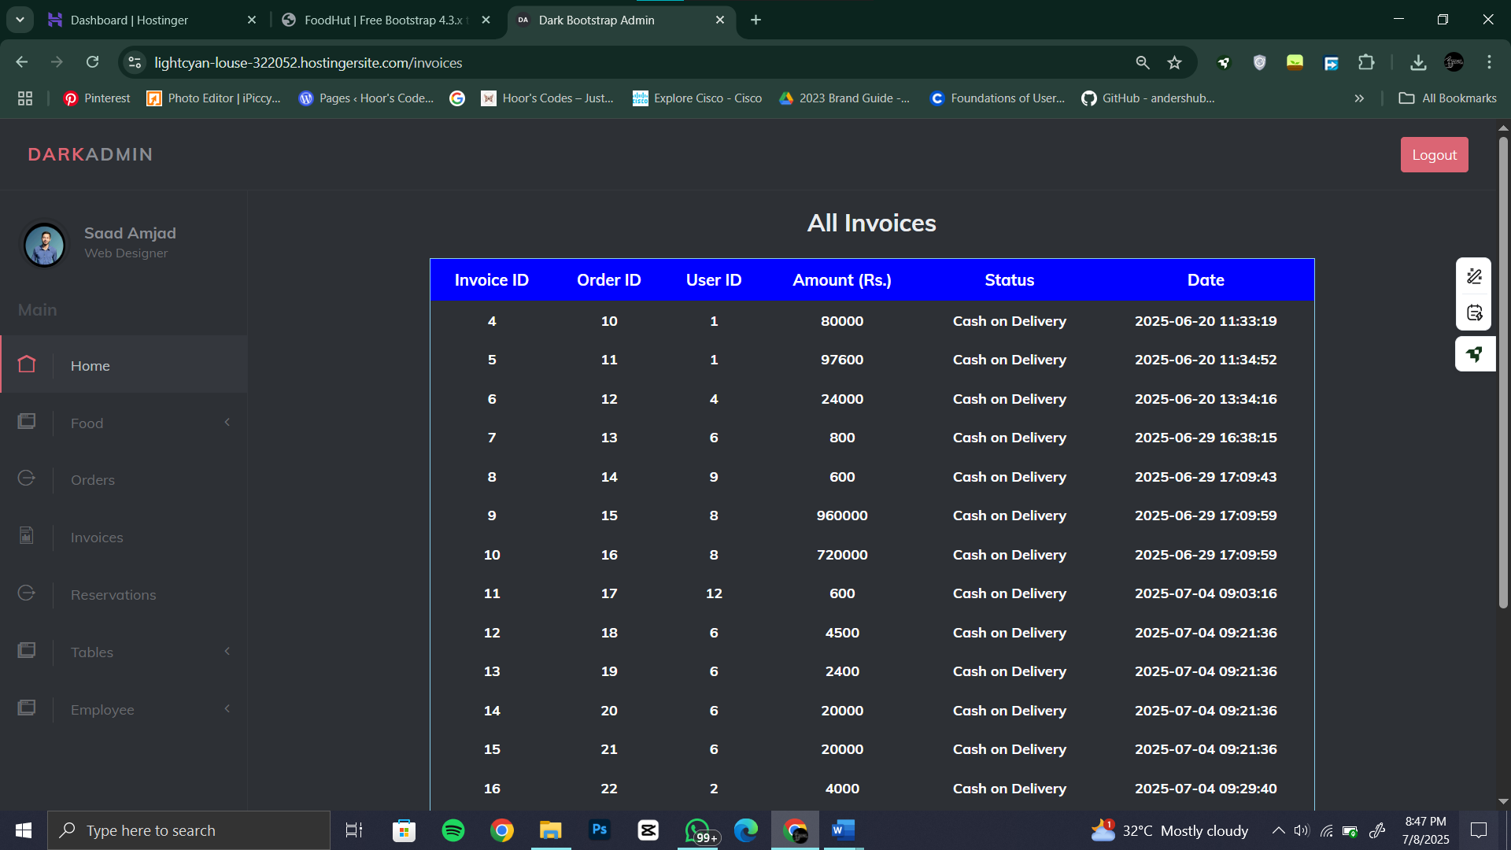

**See all reservations from admin panel:**

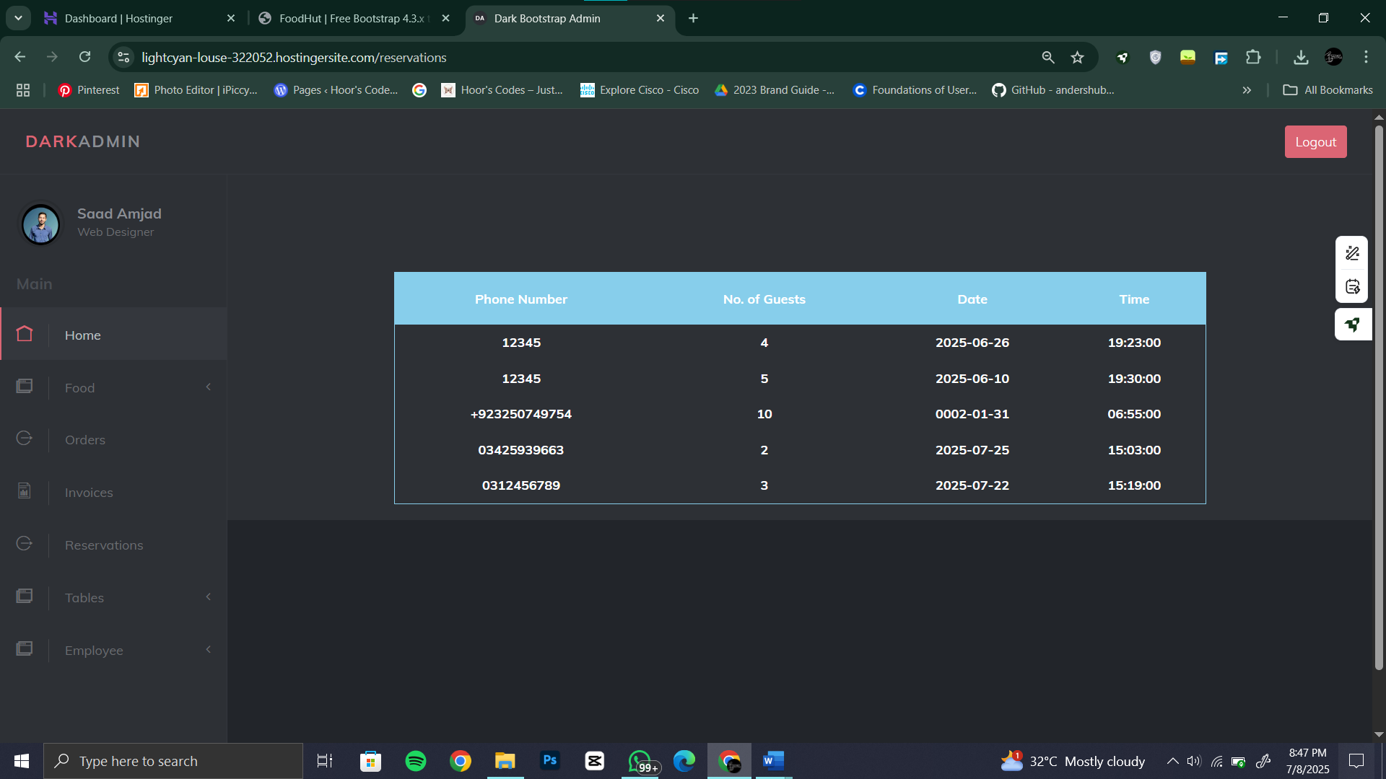

**Add table at restaurant from admin panel:**

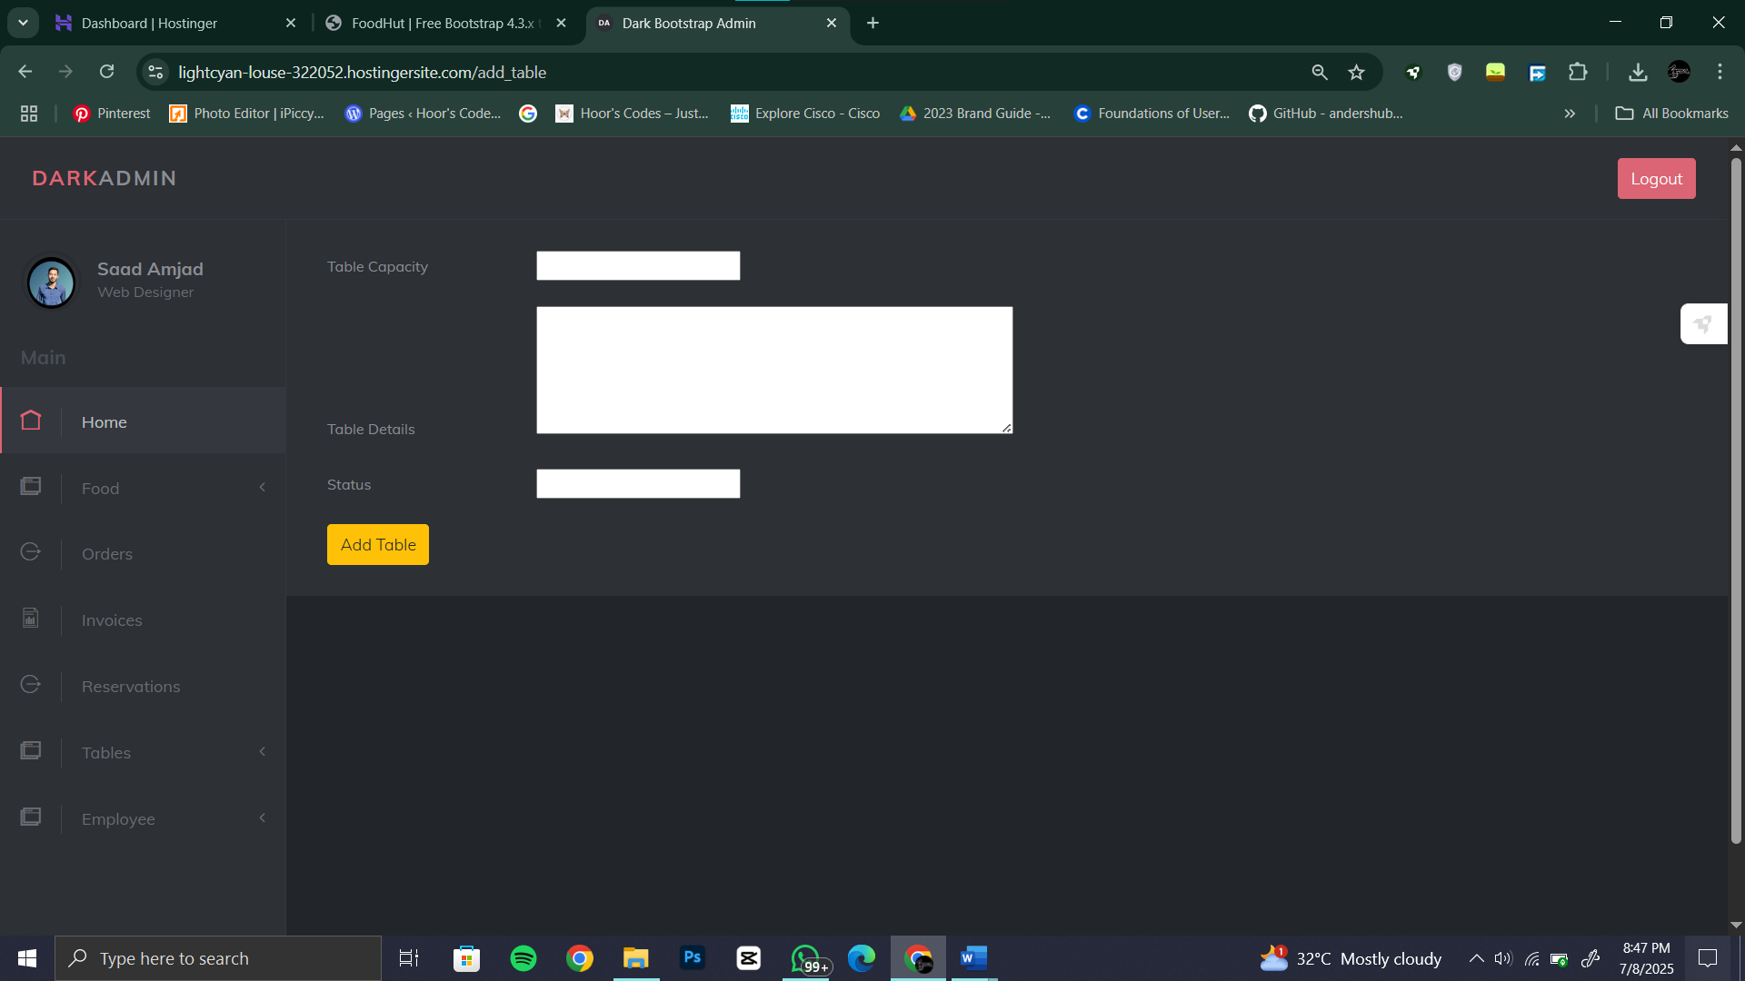

**View all available tables from admin panel:**

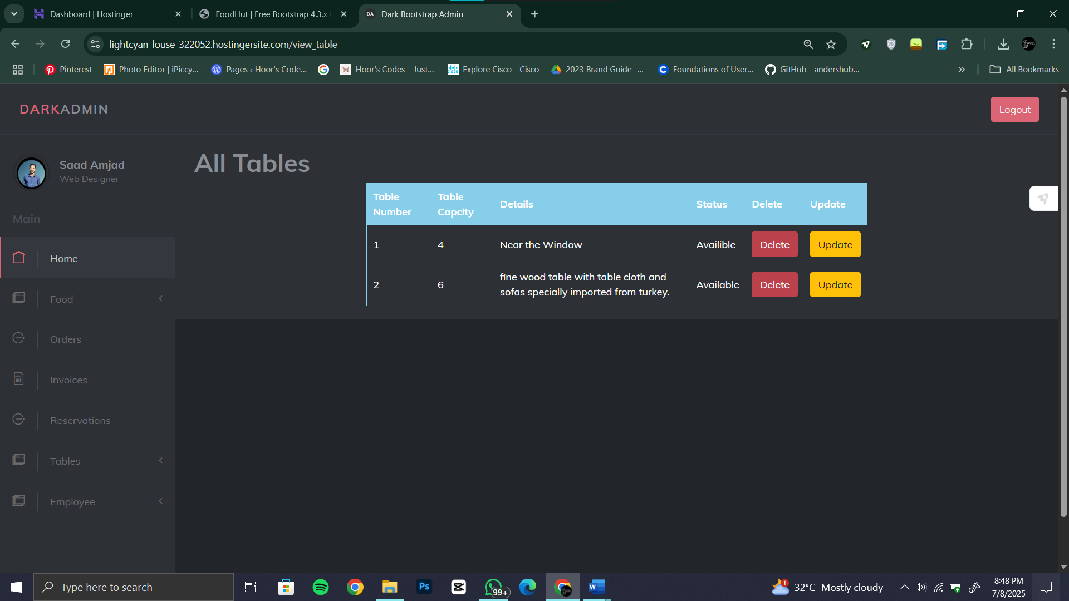

**Add employee in our restaurant from admin panel:**

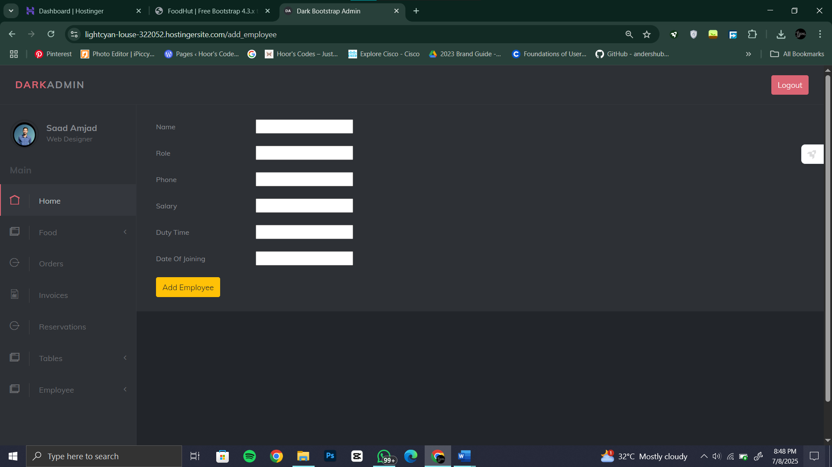

**View all employees from admin panel:**

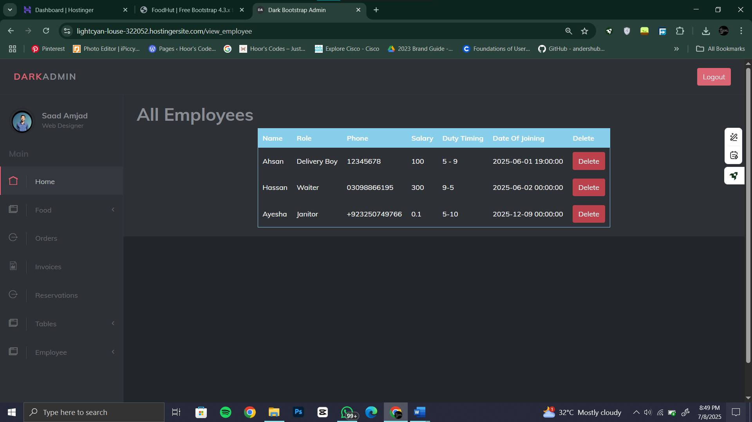

## **Website deployment dashboard :**

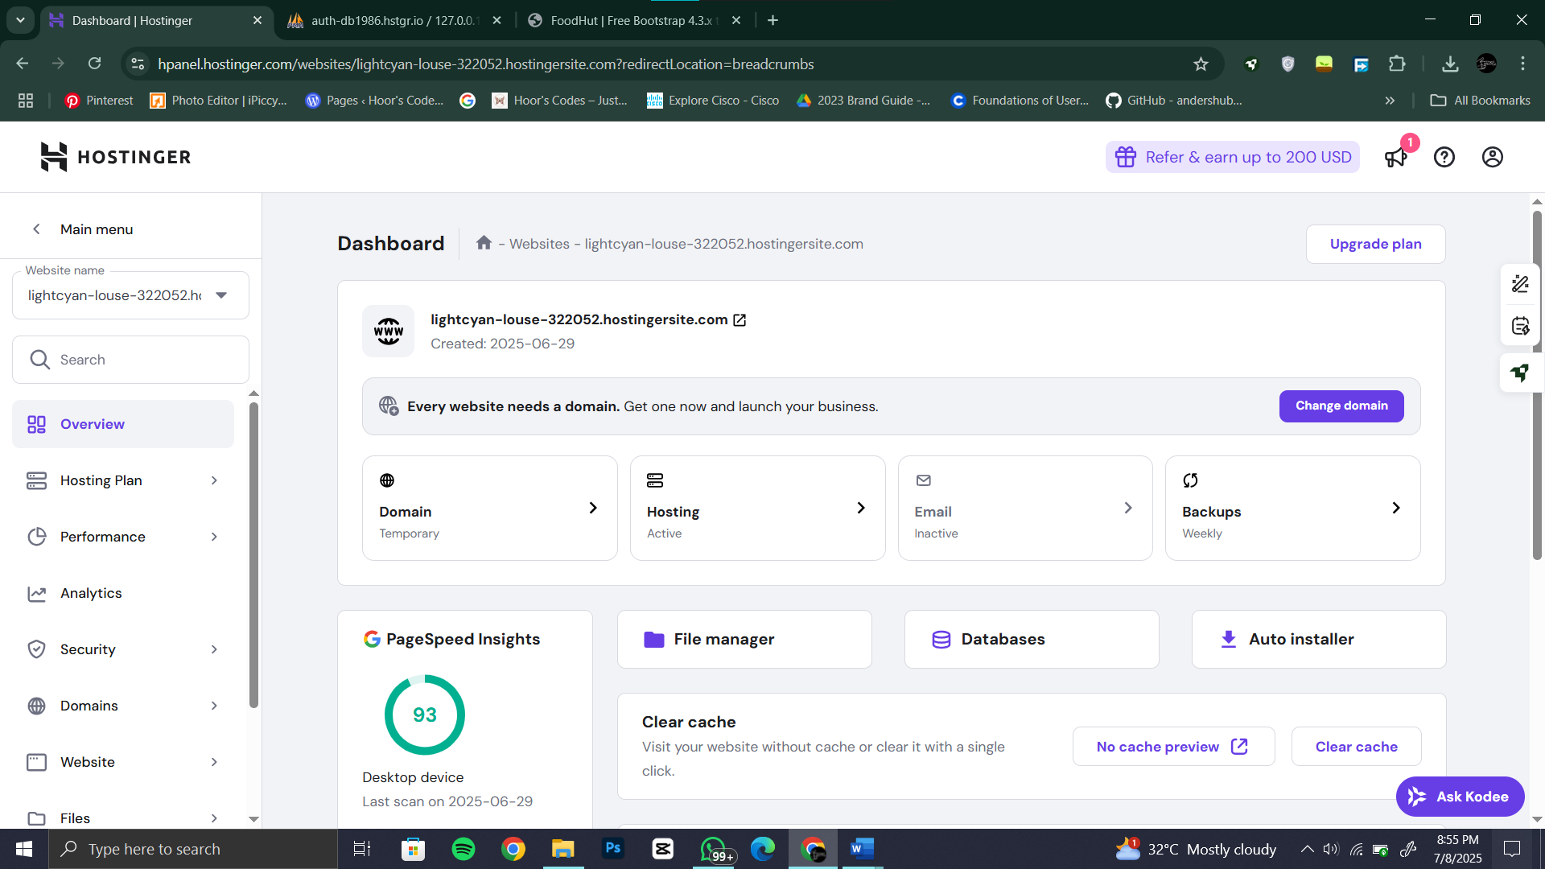

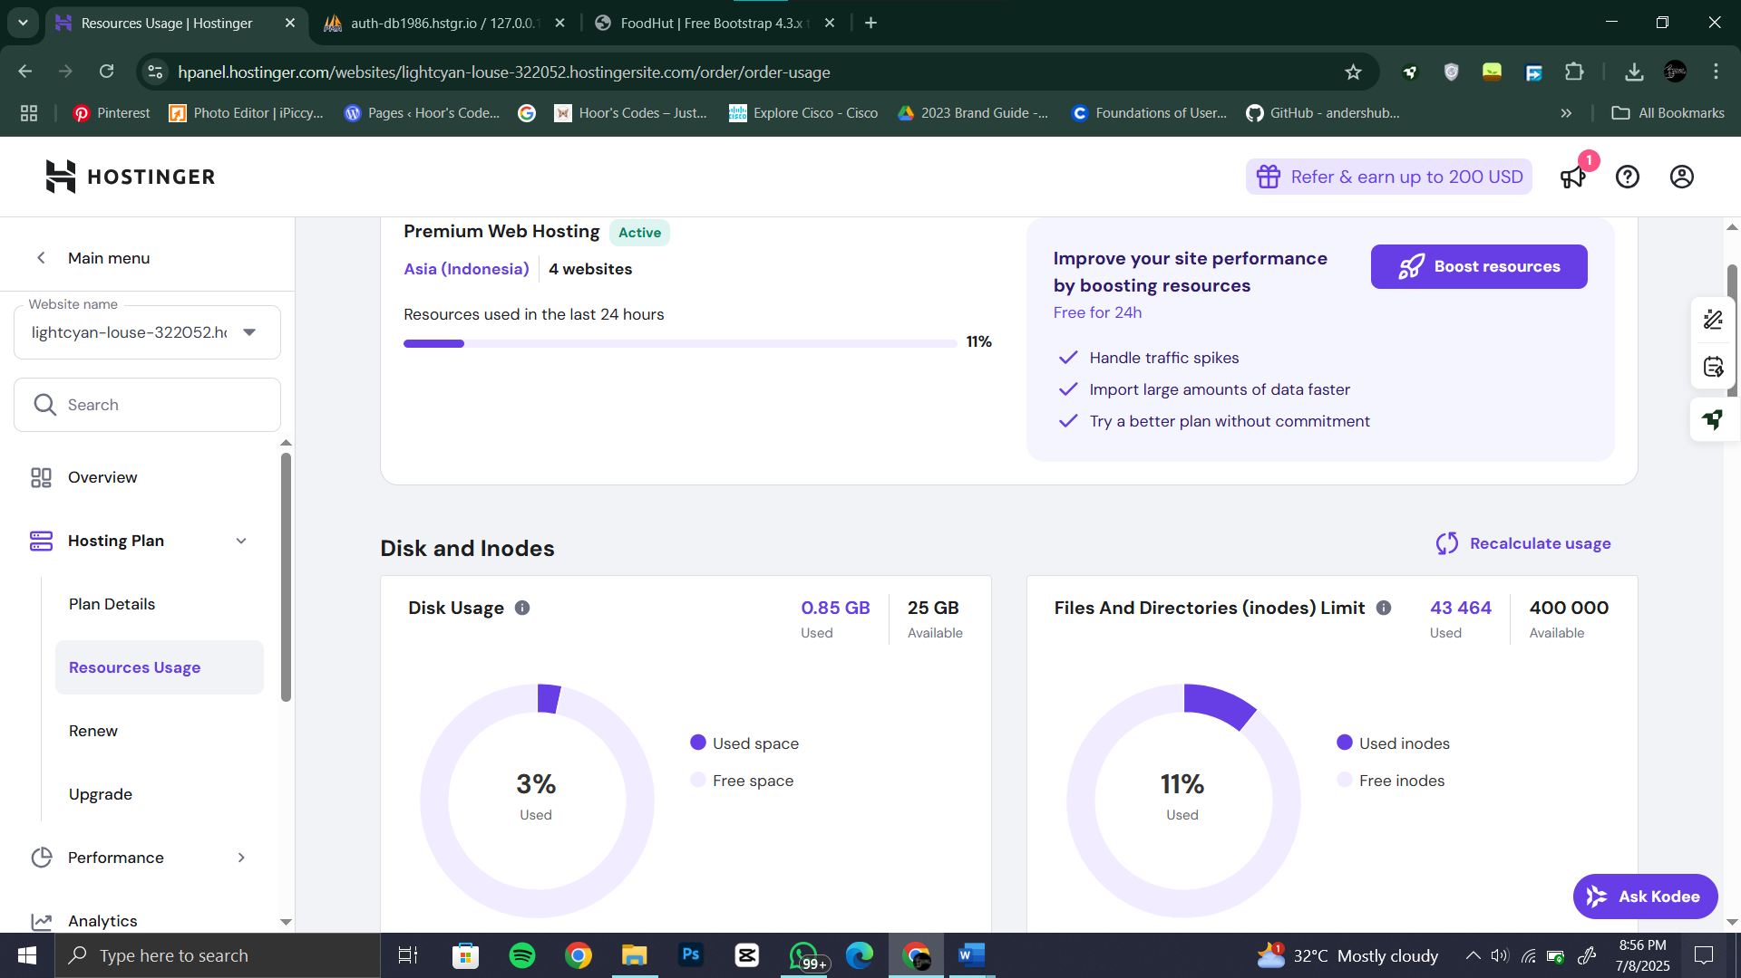

## **Website URL:**

<https://lightcyan-louse-322052.hostingersite.com/>

## **Database credentials:**

DB_DATABASE= u773711032_restaurant

DB_USERNAME= u773711032_kamiladmin

DB_PASSWORD=" Pesho@499"

## **Admin login credentials:**

Email : [admin@gmail.com](mailto:admin@gmail.com)

Password : 12345678

## **Conclusion**

The Restaurant Management System simplifies restaurant operations and enhances the customer experience. With a modular architecture and modern technologies, it can be extended further by integrating features like online payments, notification emails, or multi-branch support.

**References:**

* ChatGPT
* Youtube
* Draw.io
* Cursor AI
* Claude